**How to use AutoHotkey with 4x2 Macropad by Timception**

1. Download AutoHotkey v2.0 [Link: <https://www.autohotkey.com/>]

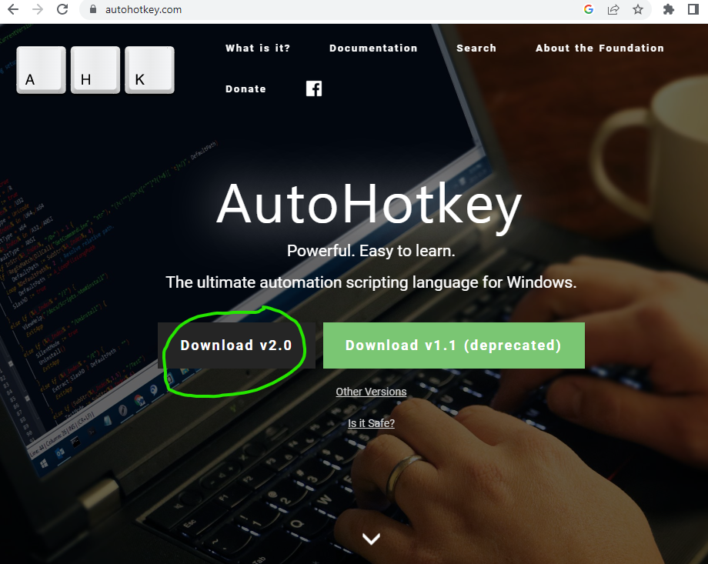

1. Install the program.

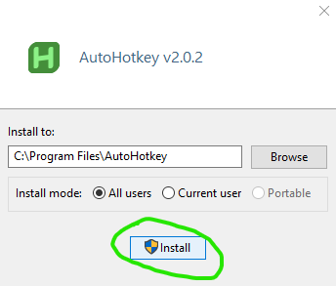

1. On your desktop, right-click and select **New > AutoHotkey Script**

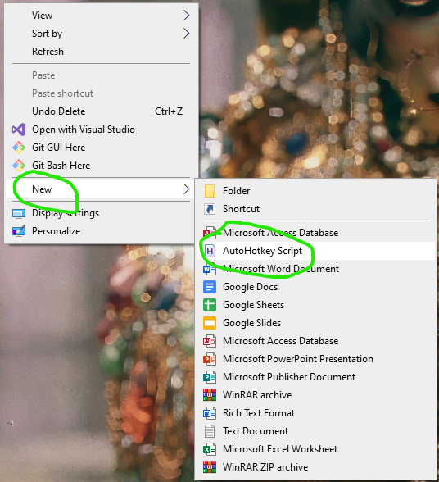

1. Name your file (in this case we named the file “**Thai**”), then click **Create**.

1. Right-click the file: **Thai.ahk** on your desktop and click **Edit script.**

1. Select **Notepad** as your editor, then click **OK**.

1. **In Notepad, paste the following script (as shown in the screenshot):**

F15::SendText "

(

This is the text that will send pasted when you press F15 on the Macropad

นี่คือข้อความที่จะถูกวางเมื่อคุณกด F15 บน Macropad

)"

F16::SendText "

(

This is the text that will send pasted when you press F16 on the Macropad

นี่คือข้อความที่จะถูกวางเมื่อคุณกด F16 บน Macropad

)"

F17::SendText "

(

This is the text that will send pasted when you press F17 on the Macropad

นี่คือข้อความที่จะถูกวางเมื่อคุณกด F17 บน Macropad

)"

F18::SendText "

(

This is the text that will send pasted when you press F18 on the Macropad

นี่คือข้อความที่จะถูกวางเมื่อคุณกด F18 บน Macropad

)"

F19::SendText "

(

This is the text that will send pasted when you press F19 on the Macropad

นี่คือข้อความที่จะถูกวางเมื่อคุณกด F19 บน Macropad

)"

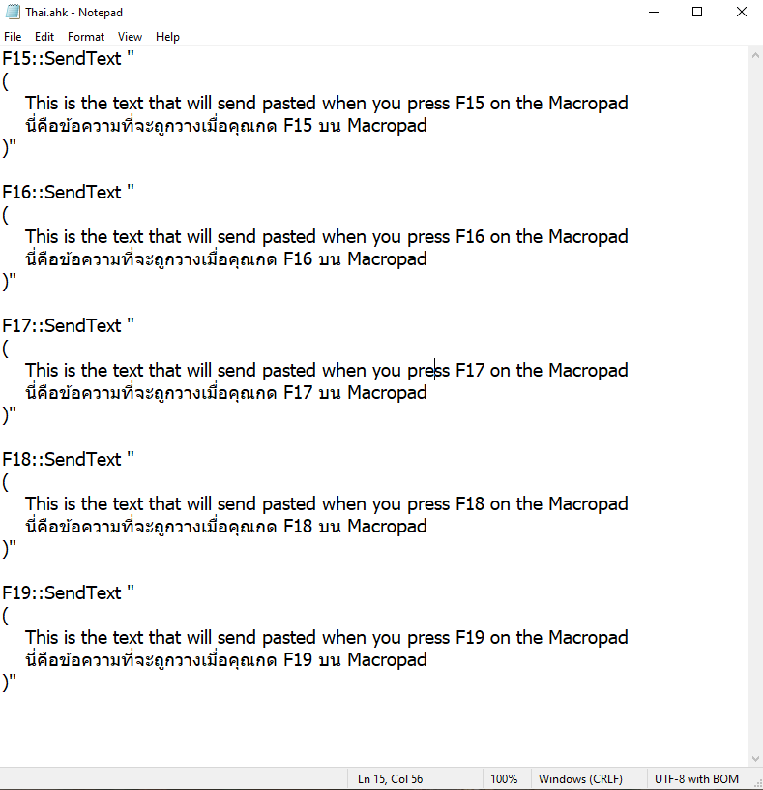

1. Save the text file: **File > Save**

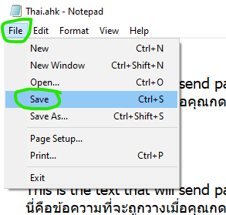

1. Download Vial to set keys on the Macropad [Link: <https://get.vial.today/download/>]

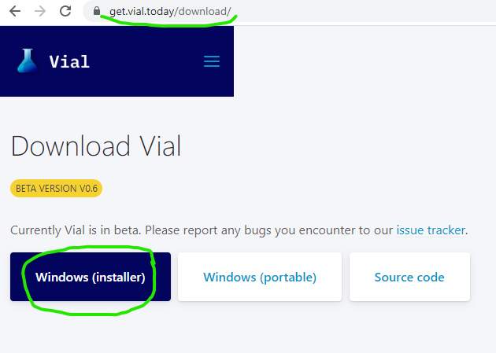

1. Double-click the installer file.

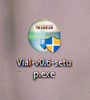

1. Click “**More info”**

1. Click “**Run anyway”**

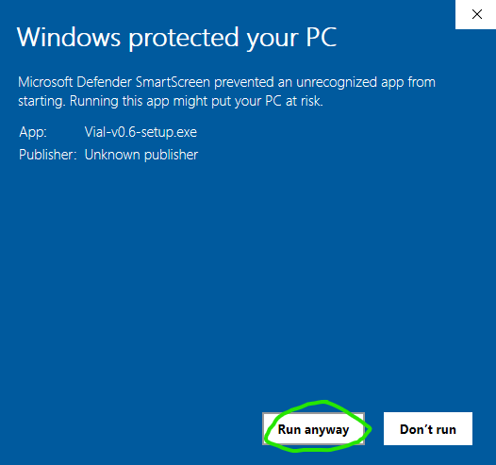

1. Install Vial

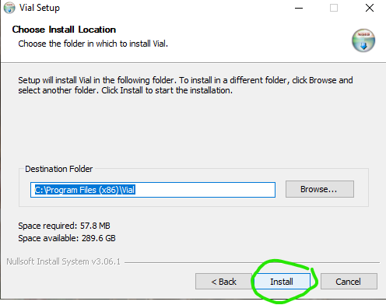

1. Check ✓**Run Vial** and Click **Finish.**

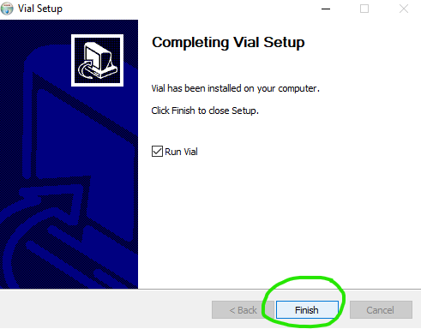

1. Click the key on the Macropad that you want to make F15.

On the bottom, click the tab “**App, Media and Mouse**” and then the key **F15**.

Do the same until you have keys F15 to F19 to use the AutoHotkey Script.

1. You can now close Vial because it already saved your settings to the Macropad.
2. On your desktop, **double-click the “Thai.ahk” file** that we saved earlier to run it.

1. You will see a small green **H** icon in the system tray.

This means your AutoHotkey Script is running.

1. Now you can open a new text file to test your Macropad and Script.

Right-click on your desktop and click **New > Text Document**

1. While in your text document, try and **press F15 on your Macropad**, you should see the following text pasted.

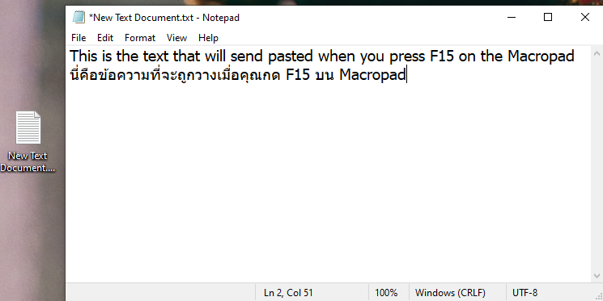

1. Whenever you change your script file, please do not forget to **Reload Script**

You can do this by right-clicking the AutoHotkey system tray icon and clicking Reload Script.

1. When you do not want to use the AutoHotkey Script, just **Right-Click AutoHotkey and Exit**

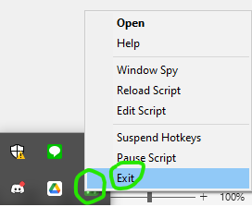

1. Please follow me at [www.instagram.com/keykraft](http://www.instagram.com/keykraft) to see my new keyboard creations.